Southport Congregational Church
United Church of Christ
524 Pequot Avenue
Southport, Connecticut 06890
office@southportucc.org
Rev. Paul Whitmore, Senior Minister Rev. Laura Whitmore, Associate Minister
Julie Center, Student Minister
__________________________________________________________________________________________________________________________________

SUNDAY SERVICE OF WORSHIP
October 10, 2021, at ten o’clock

PRELUDE “Arietta” Marcello
“Minuet” G.F. Handel Meredith Moore, French Horn
Elaine DeGrood, Piano

*HYMN “Be Thou My Vision” (see insert)

*THE CALL TO WORSHIP Rev. Laura Whitmore

Leader: Let us gather this hour, in the grace, peace, strength, hope and good courage that our Lord provides.

People: Because God has put a new song in our mouths, we will sing our praise to God with thanks.

Leader: Because God not only blesses us, but hears our pleas, let us put our trust in God’s steadfast love.

People: Because God’s law has been written upon our hearts, we try to live our daily lives doing God’s will.

Leader: In our worship and in our life, may we celebrate God’s grace and gifts in all we say and do.

People: Gathering in the thankfulness and joy, let us commit all that God has given to us for the celebration of life, and for the care of all people.

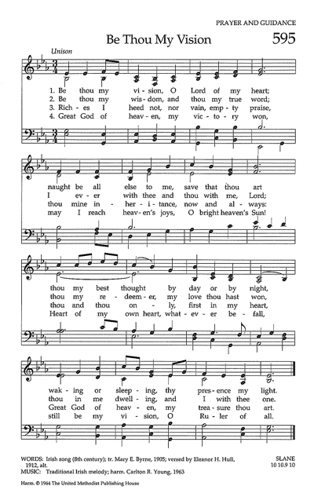

*THE INVOCATION & LORD’S PRAYER (Trespasses)

*GLORIA PATRI

Glory be to the Father, and to the Son, and to the Holy Ghost;
As it was in the beginning, is now, and ever shall be, world without end. Amen.

OPPORTUNITIES AND ANNOUNCEMENTS FOR OUR CHURCH FAMILY
Rev. Paul Whitmore

CHILDREN’S SERMON Rev. Laura Whitmore

*HYMN “I Love To Tell The Story” (see insert)

PASTORAL PRAYER

CALL TO OFFERING

To give towards your 2021 Stewardship Pledge Contribution or make a plate donation, please text as follows:

Text: 860-854-1995
$____Pledge
$____Plate

To give online, please visit our website at southportucc.org

To mail us your offering or pledge, please send a check to:
Southport Congregational Church, PO Box 366, Southport, CT 06890

Thank you!

OFFERTORY “May The Lord Show His Mercy Upon You” Rutter Senior Choir

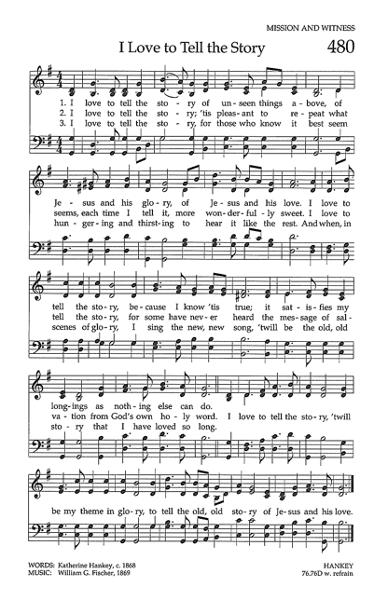
UNISON PRAYER OF DEDICATION

Our faith in You, God, reveals itself in the generosity with which we give. Accept these offerings as a sign of our love for You, and our commitment to honor You in our lives and in our world. Amen.

SCRIPTURE GENRES IN THE BIBLE (see insert)

2 Timothy 3:16-17

16 All scripture is inspired by God and is useful for teaching, for reproof, for correction, and for training in righteousness, 17 so that everyone who belongs to God may be proficient, equipped for every good work.

SERMON “READ INTO IT!” Julie Center

* HYMN “Blessed Assurance” (see insert)

*BENEDICTION

*BENEDICTION RESPONSE “Go in Peace” Senior Choir & Congregation

Go in peace and the peace of God be with you this day.
Go in peace and the peace of God be with you always.
Celebrate and share the joy! Celebrate new life!
Go in peace and the peace of God be with you always.

POSTLUDE “Air” From Water Music, Handel
Meredith Moore, French Horn
Elaine DeGrood, Organ

~~~~~~~~~

PLEASE JOIN US FOR FELLOWSHIP HOUR Following worship, we invite you to join us in the Courtyard for a special time of conversation and Mexican food refreshments (Julie’s favorite) provided by the Fellowship Committee.

A HISTORIC TOUR OF SOUTHPORT AND ITS HISTORY WITH THE PEQUOT WAR will be held today, immediately following worship. Join archeologist and historian, David Naumec, as he shares the story of what really happened in Southport during the Pequot War. Please wear or bring your sneakers and prepare for a nice walk!
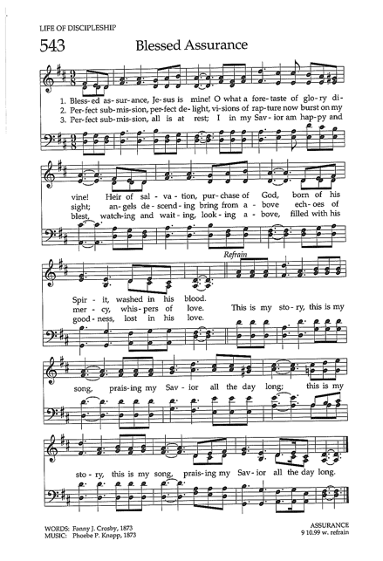
1:00 P.M. TODAY - SENIOR HIGH YOUTH GROUP PIZZA PARTY AND ARCHEOLOGICAL DIG!

THIS TUESDAY, OCTOBER 12 AT 5:30 P.M. Deacon Confirmand Dinner.

SENIOR CHOIR rehearses in the Sanctuary on Sundays at 9:00 a.m., and in the Music Room at 11:15 a.m.

MARK YOUR CALENDAR - OKTOBERFEST IS BACK! Join the Fellowship Committee for a night of everything German: Food, Music, Dance and Clothing! On Friday, October 15, all adult members are invited to join in a fun night of being together and welcoming Fall! The festivities will begin at 6:00 p.m. A formal invitation was e-mailed on October 7 and RSVPs must be in by Monday at 5:00 p.m.

RWAV OPENS ONE MONTH FROM TOMORROW - TICKETS ARE NOW ON SALE! We are delighted to announce that we will be holding our annual fundraiser this year! The Opening Party is Thursday, November 4 and the show runs through Sunday, November 7. Visit roomswithaview.org to purchase tickets to all events. For the Opening Party, we are happy to offer a special discount price of $100 to seniors who are also church members! Purchasing the discount tickets can only be done through the church office - please contact Pam at ppoling@southportucc.org to do so.

MIDDLE SCHOOL YOUTH GROUP will be held on Tuesday from 4:00 p.m. to 5:15 p.m. led by Student Minister, Julie Center. We welcome all Middle Schoolers to join!

USHERING AND GREETING YOU TODAY are Deacons Jeff Provost and Jeffrey Earls, under the direction of Deacon Katie Traynor.

WE THANK OUR TALENTED MUSICIANS, Elaine DeGrood and the Senior Choir, and Special Guest Meredith Moore on the French Horn, for today’s beautiful music.

THIS WEEK’S ALTAR FLOWERS are given by Barbara Abbott in honor of her daughter Susan, on her birthday, with appreciation of her support during the pandemic.

THANKS TO THIS WEEK’S LIVESTREAM “DREAM TEAM” techs Thank you to Parker Whitmore, Henry Schott for their help with the live streaming of today’s service.

THE MEN’S DISCUSSION GROUP meets every Thursday at 7:00 a.m. in the Youth Room, led by Rev. Paul Whitmore. All men are welcome for fascinating discussions each week integrating current events, faith and spirituality, psychological insights and much more! Email Paul at pwhitmore@southportucc.org to receive the weekly topic email blast. Zoom option is available.

THE WOMEN’S DISCUSSION GROUP meets every Thursday at 11:30 a.m. in the Youth Room, led by Rev. Laura Whitmore. Join Laura to discuss current events, spirituality, and new psychological ideas and much more. Email Laura at lwhitmore@southportucc.org to be put on the list. Zoom option is available.

